Project Planning Phase
Project Planning Template (Product Backlog, Sprint Planning, Stories, Story points)

Date | 18 june 2026
Team ID
Project Name | SHOPEZ – E-Commerce Application
Maximum Marks

Product Backlog, Sprint Schedule, and Estimation (4 Marks)

Product Backlog, Sprint Schedule and Estimation
Sprint | Functional Requirement (Epic) | User Story Number | User Story / Task | Story Points | Priority | Team Members
Sprint-1 | User Registration | USN-1 | As a user, I can register using email and password. | 2 | High | Ballari Vinuthna
Sprint-1 | User Login | USN-2 | As a user, I can log in securely. | 2 | High | Ballari Vinuthna
Sprint-1 | Authentication | USN-3 | As a user, I can logout from the application. | 1 | Medium | Ballari Vinuthna
Sprint-2 | Product Management | USN-4 | As a user, I can browse all available products. | 3 | High | Ballari Vinuthna
Sprint-2 | Product Search | USN-5 | As a user, I can search products by name. | 2 | High | Ballari Vinuthna
Sprint-2 | Product Details | USN-6 | As a user, I can view detailed product information. | 2 | High | Ballari Vinuthna
Sprint-3 | Cart Management | USN-7 | As a user, I can add products to cart. | 3 | High | Ballari Vinuthna
Sprint-3 | Cart Management | USN-8 | As a user, I can update or remove cart items. | 2 | High | Ballari Vinuthna
Sprint-3 | Order Processing | USN-9 | As a user, I can place an order successfully. | 3 | High | Ballari Vinuthna
Sprint-4 | Order Tracking | USN-10 | As a user, I can track my orders. | 2 | Medium | Ballari Vinuthna
Sprint-4 | Admin Dashboard | USN-11 | As an admin, I can manage products. | 3 | High | Ballari Vinuthna
Sprint-4 | Admin Dashboard | USN-12 | As an admin, I can manage users and orders. | 3 | High | Ballari Vinuthna

Project Tracker, Velocity & Burndown Chart
Sprint | Total Story Points | Duration | Sprint Start Date | Sprint End Date (Planned) | Story Points Completed | Sprint Release Date (Actual)
Sprint-1 | 15 | 6 Days | 15 Feb 2026 | 20 Feb 2026 | 15 | 20 Feb 2026
Sprint-2 | 18 | 6 Days | 22 Feb 2026 | 27 Feb 2026 | 18 | 27 Feb 2026
Sprint-3 | 20 | 6 Days | 01 Mar 2026 | 06 Mar 2026 | 20 | 06 Mar 2026
Sprint-4 | 20 | 6 Days | 08 Mar 2026 | 13 Mar 2026 | 20 | 13 Mar 2026

Velocity Calculation
Total Story Points Completed = 73
Number of Sprints = 4
Average Velocity = 73 ÷ 4 = 18.25 Story Points per Sprint
If sprint duration is 6 days:
Average Velocity Per Day = 18.25 ÷ 6 = 3.04 Story Points/Day

Burndown Chart:
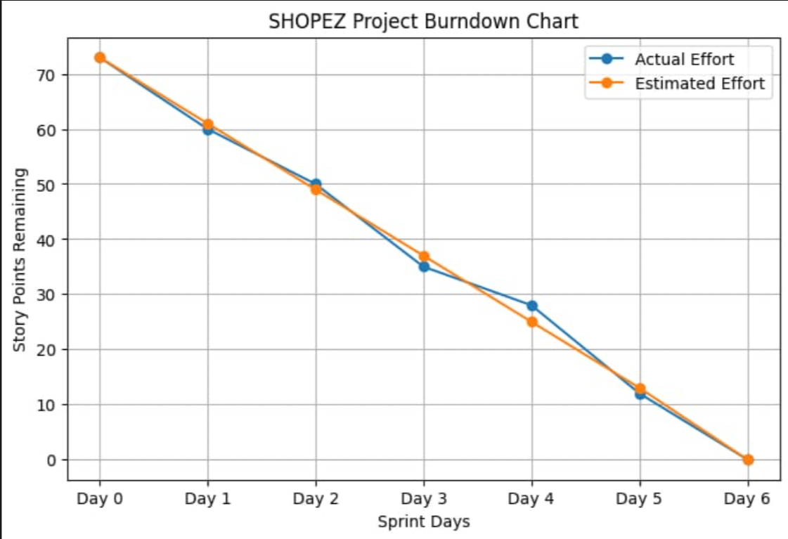

Data Used
Day | Estimated Effort | Actual Effort
Day 0 | 73 | 73
Day 1 | 61 | 60
Day 2 | 49 | 50
Day 3 | 37 | 35
Day 4 | 25 | 28
Day 5 | 13 | 12
Day 6 | 0 | 0

Description to Paste Below the Chart
The burndown chart illustrates the progress of the SHOPEZ E-Commerce Application development during the sprint cycle. The estimated effort line represents the planned completion of story points, while the actual effort line shows the real progress achieved by the developer. The chart demonstrates that the project was completed successfully within the planned timeline, with all story points completed by the end of the sprint.
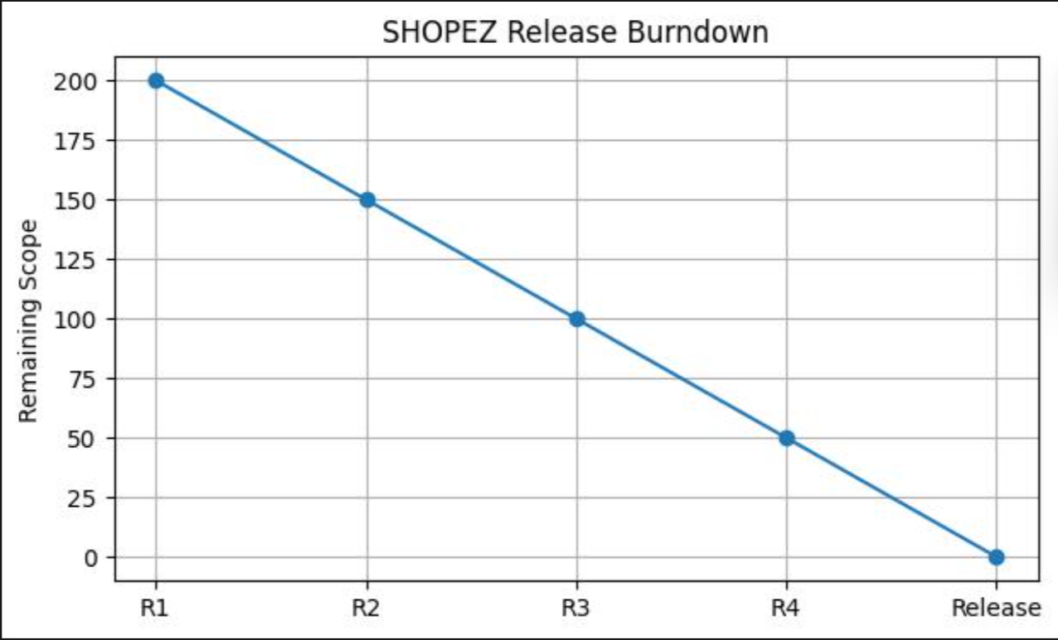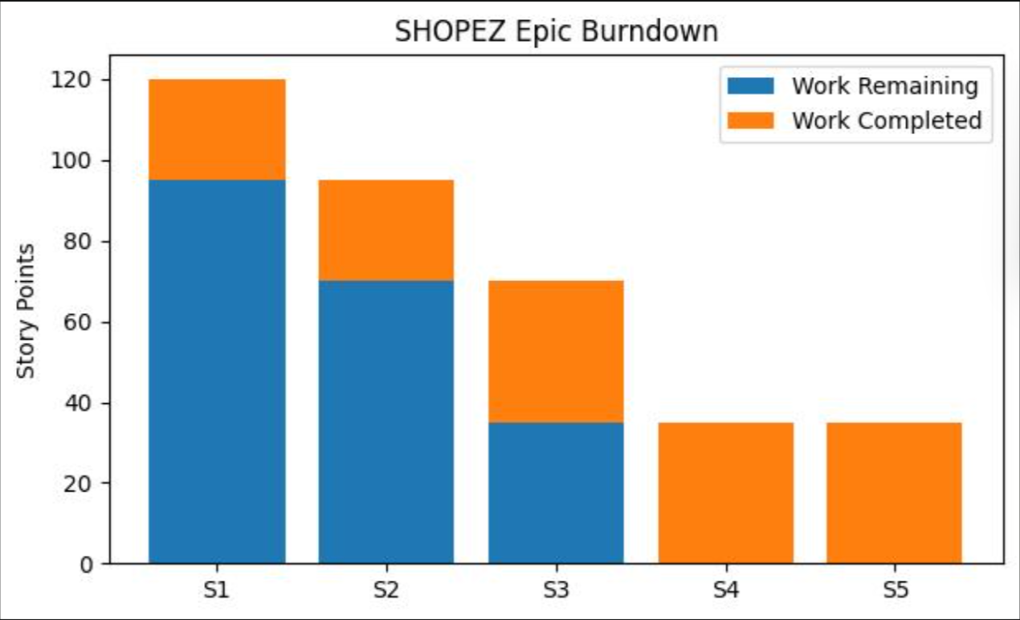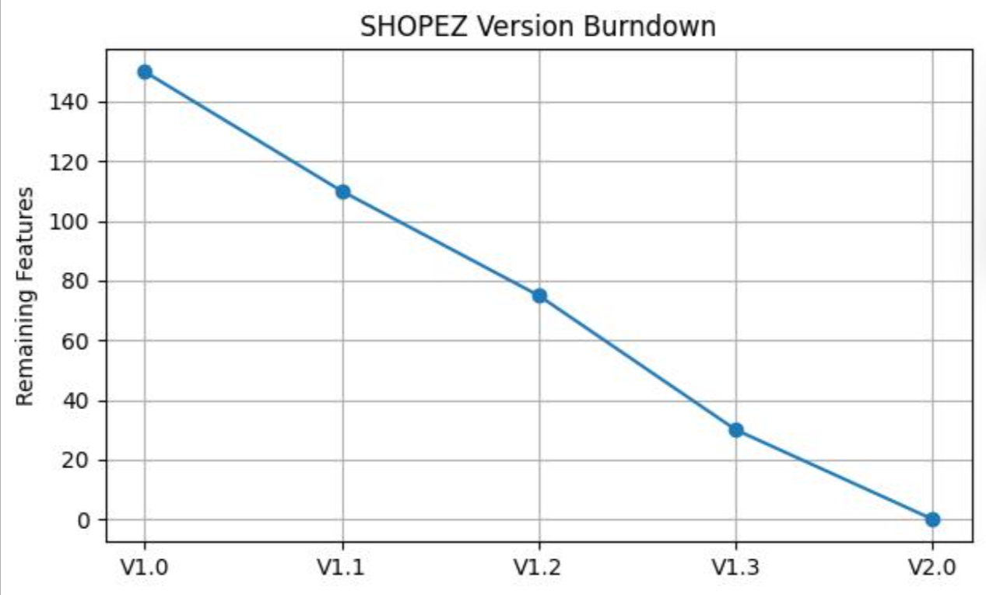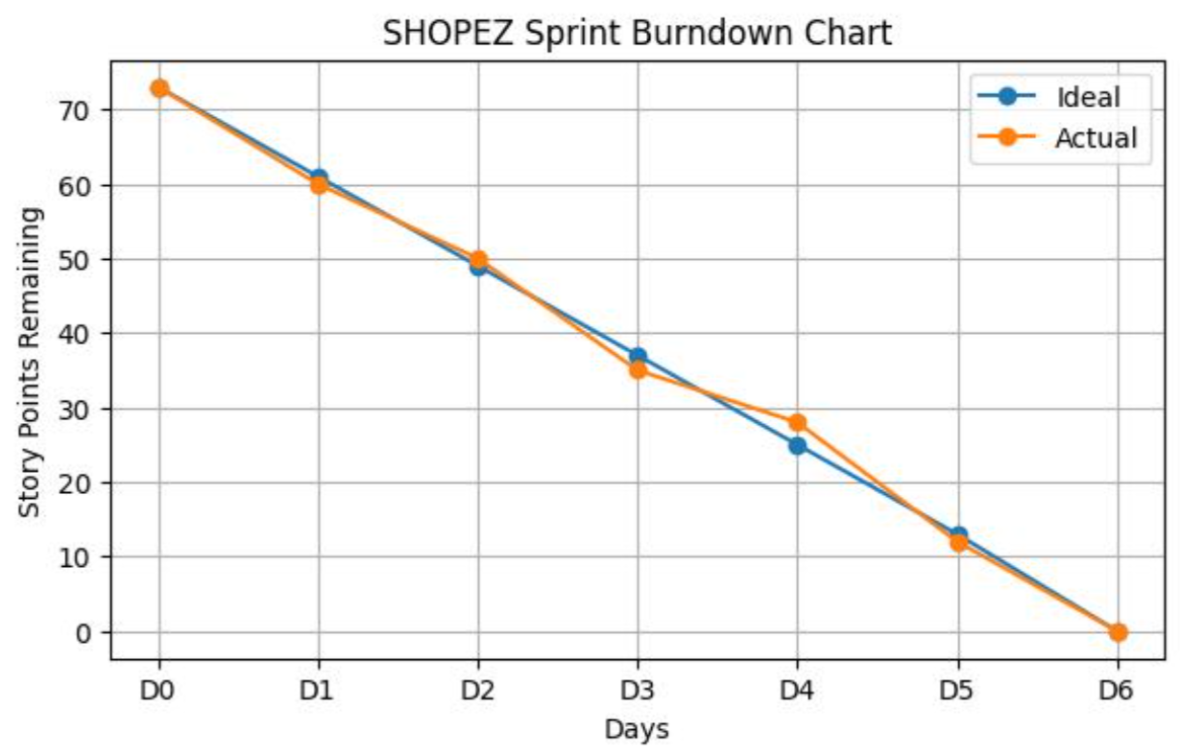
A burn down chart is a graphical representation of work left to do versus time. It is often used in agile software development methodologies such as Scrum. However, burn down charts can be applied to any project containing measurable progress over time.

https://www.visual-paradigm.com/scrum/scrum-burndown-chart/
https://www.atlassian.com/agile/tutorials/burndown-charts

Reference:
https://www.atlassian.com/agile/project-management
https://www.atlassian.com/agile/tutorials/how-to-do-scrum-with-jira-software
https://www.atlassian.com/agile/tutorials/epics
https://www.atlassian.com/agile/tutorials/sprints
https://www.atlassian.com/agile/project-management/estimation
https://www.atlassian.com/agile/tutorials/burndown-charts

